**DAILY ONLINE ACTIVITIES SUMMARY**

|  |  |  |  |  |  |  |  |  |
| --- | --- | --- | --- | --- | --- | --- | --- | --- |
| **Date:** | **26/06/2020** | | | | | **Name:** | **SUJAYA** | |
| **Sem & Sec** | **IV sem & B section** | | | | | **USN:** | **4AL18CS090** | |
| **Online Test Summary** | | | | | | | | |
| **Subject** | | **-** | | | | | | |
| **Max. Marks** | | **30** | | **Score** | | | **-** | |
| **Certification Course Summary** | | | | | | | | |
| **Course** | **Blockchain Basics** | | | | | | | |
| **Certificate Provider** | | | **Greatlearning academy** | | **Duration** | | | **2.5hours** |
| **Coding Challenges** | | | | | | | | |
| **Problem Statement1:** Given start and end of a range, write a Python program to print all negative numbers in given range. | | | | | | | | |
| **Status: Executed** | | | | | | | | |
| **Uploaded the report in Github** | | | | | **YES** | | | |
| **If yes Repository name** | | | | | **Online-coding** | | | |
| **Uploaded the report in slack** | | | | | **YES** | | | |

Online Test Summary: No internals conducted today.

Online Certification Course Summary: In today’s session I have learnt about proof of work and proof of stake, what exactly it is and how it is used in blockchain technology.

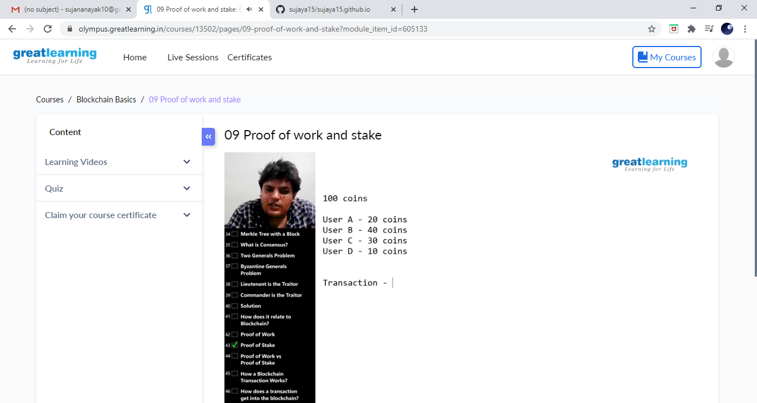

These are the snap shots of today’s session.

Online Coding Summary: **Today I had received one program from prof. Vasudev CSE Dept. The program is mentioned above in the coding challenges. I have also uploaded it to my Github repository.**

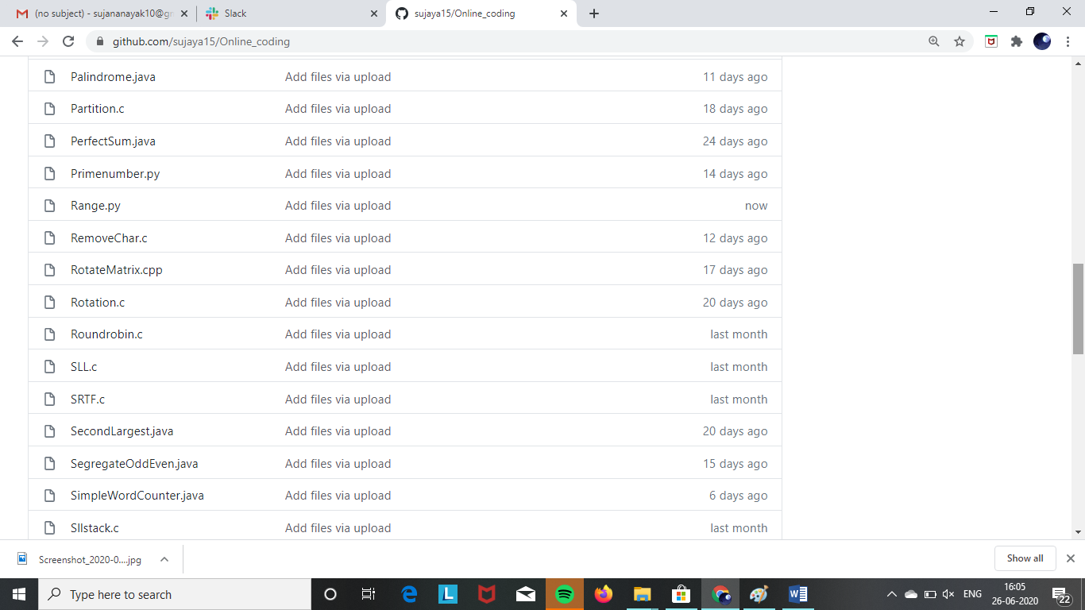

This is the snap shot of my repository were I have uploaded the code. File name is Range.py

Online Training: Today I had attended the online training organized by CSE Department AIET. The training was on Cyber Security and its Applications done by Dr. Manjunath Kotari HOD CSE Dept. After the session the quiz was conducted.

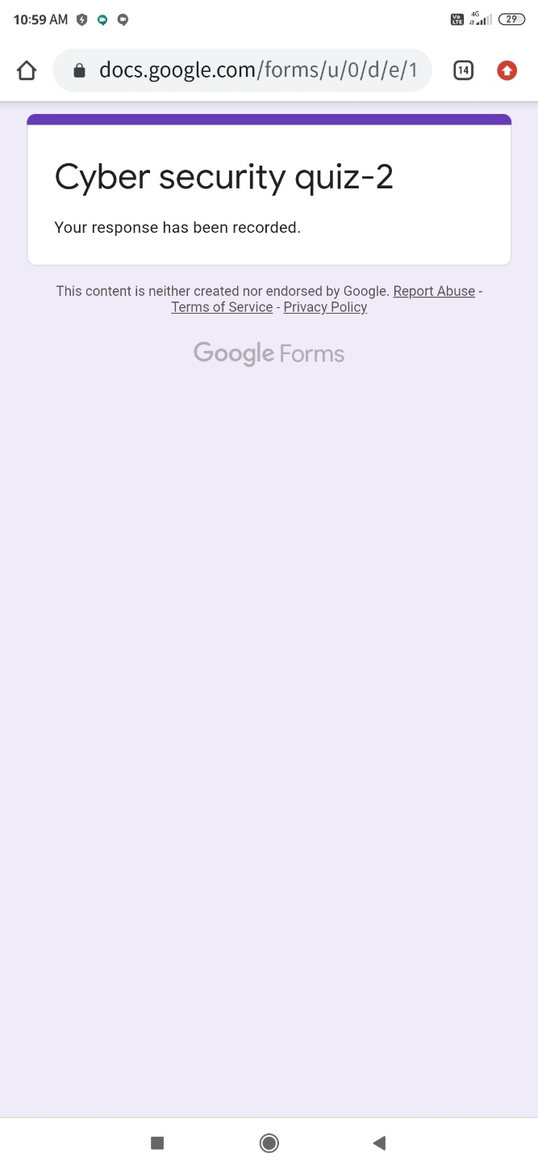

**This is the snap shot of the quiz attempted.**